**9921103163**

**NITIN CHAUDHARY**

**F8**

**ANS-1-**

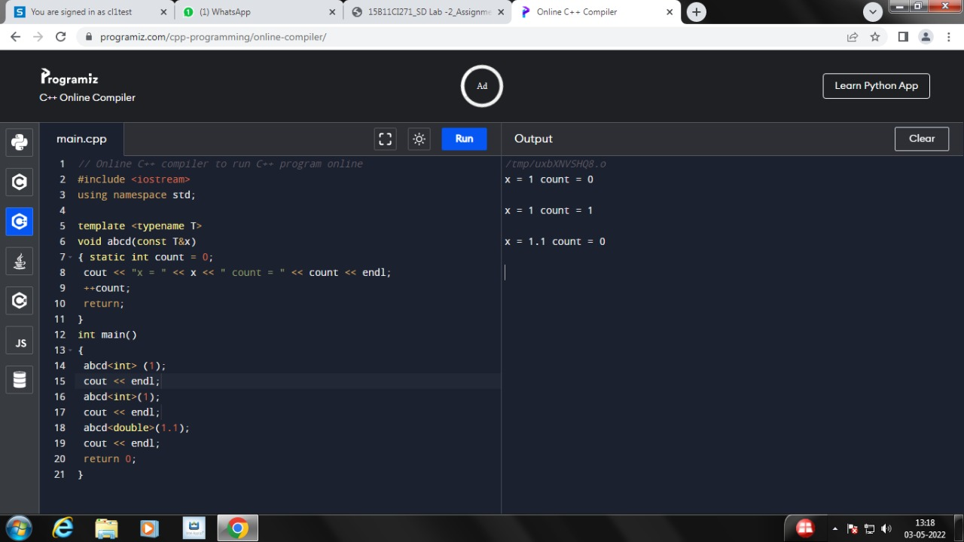

**Ans 2-**

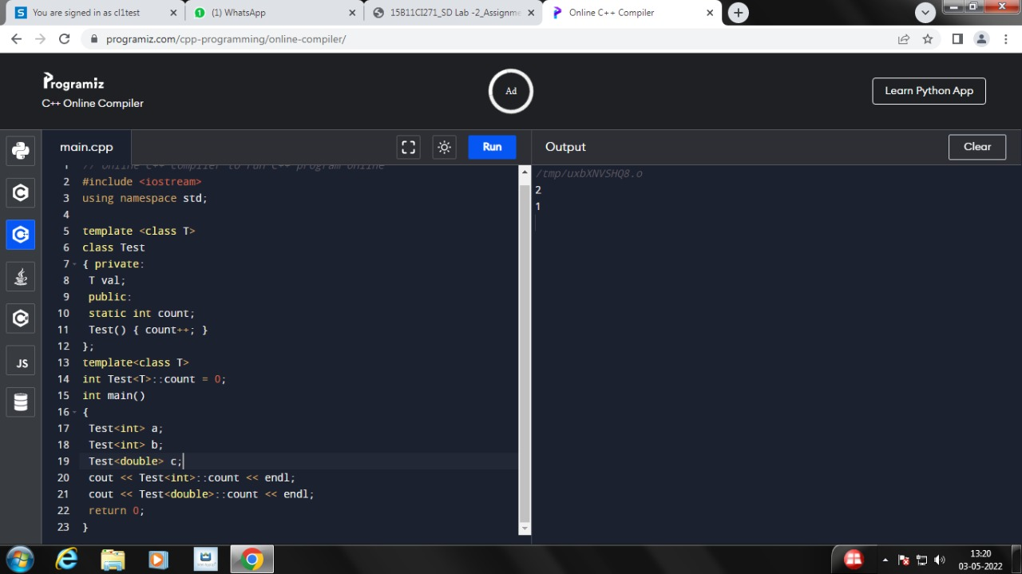

**Ans 3-**

**#include<iostream>**

**using namespace std;**

**template <class calculator>**

**class X {**

**calculator a,b;**

**public:**

**X(calculator a, calculator b){**

**this->a=a;**

**this->b=b;}**

**calculator add(){**

**cout<<"addition of two numbers:"<<a+b<<endl;**

**return a+b;**

**}**

**calculator sub(){**

**cout<<"subtration of two numbers:"<<a-b<<endl;**

**return a-b;**

**}**

**calculator mul(){**

**cout<<"Multiplication of two numbers:"<<a*b<<endl;**

**}**

**calculator div(){**

**cout<<"division of two numbers:"<<a/b<<endl;**

**}**

**};**

**int main(){**

**X<int> obj(7,8);**

**obj.add();**

**obj.sub();**

**obj.mul();**

**obj.div();**

**X<float> obj1(7.1,8.1);**

**obj.add();**

**obj.sub();**

**obj.mul();**

**obj.div();**

**X<double> obj2(7,8);**

**obj.add();**

**obj.sub();**

**obj.mul();**

**obj.div();**

**}**

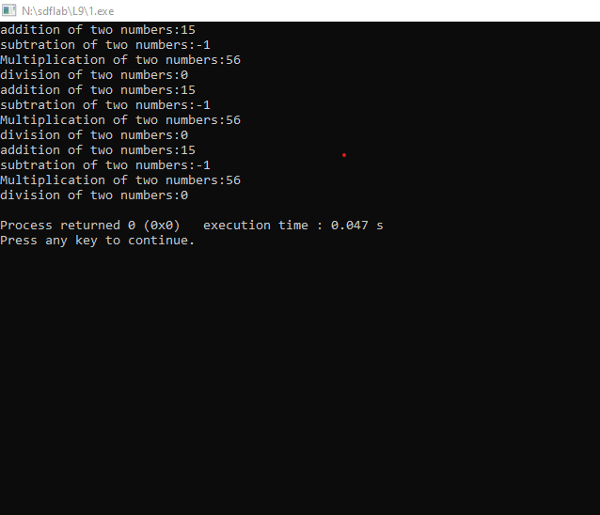

**Ans 4-**

**#include<iostream>**

**using namespace std;**

**template<class x>**

**x Minimum(x a,x b){**

**if(a<b)**

**return a;**

**return b;**

**};**

**template<class x>**

**x Maximum(x a, x b){**

**if(a>b)**

**return a;**

**return b;**

**}**

**int main(){**

**int var,var1;**

**cout<<"Enter two values of int type: ";**

**cin>>var>>var1;**

**cout<<"Minimum value is:"<<Minimum(var,var1);**

**cout<<endl<<"Maxumum value is:"<<Maximum(var,var1);**

**cout<<"\nEnter two values of float type: ";**

**float var2,var3;**

**cin>>var2>>var3;**

**cout<<"Minimum value is:"<<Minimum(var2,var3);**

**cout<<endl<<"Maxumum value is:"<<Maximum(var,var1);**

**cout<<"\nEnter two values of double type: ";**

**double var4,var5;**

**cin>>var4>>var5;**

**cout<<"Minimum value is:"<<Minimum(var4,var5);**

**cout<<endl<<"Maxumum value is:"<<Maximum(var4,var5);**

**}**

